Jewish Genealogy Society of Cleveland: 40th Anniversary Honorary Co-Chairs

Russ Maurer

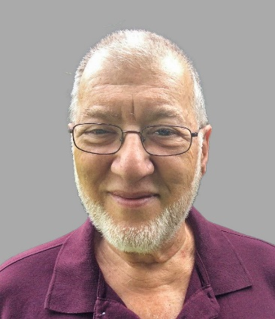
My roots in genealogy and genetics are deep. I was trained as a molecular biologist, so I have a professional level understanding of genetic mechanisms and the genetic basis of genealogy. Family research in my family began with my father, the late Ely Maurer, in the 1980s. He was one of the pioneers of genealogy research in eastern European archives, at a time when this was almost unheard of because there was still the Iron Curtain, and the Internet was yet to be invented. He left us with two long reports, one about his mother's (Galician) family and one about his father's (also Galician) family, as well as preliminary research on my mother's (Litvak) ancestry. Some years ago, I picked up where my father left off, becoming skilled at using the tools available today as I developed detailed ancestral trees for all four of my grandparents, as well as my wife's Irish-German-Polish ancestors.

I am self-taught in Polish, and I have a rudimentary knowledge of Russian from having studied it in college, long ago. I have completed several volunteer Polish language translation projects for LitvakSIG as well as for Galician groups.

In recent years I have worn a variety of genealogy "hats", including
*Member of the Board for both LitvakSIG and JGSC
*Town or District coordinator for both JRI-Poland and LitvakSIG
*Research chair for JGSC
*Moderator for the Jewish Tarnow Facebook group

I am probably best known for my contributions as Records Acquisition & Translation coordinator, as well as coordinator of the Vilnius Household Registers project, both for LitvakSIG.

In 2021 I was honored to be named the Nolan Altman Volunteer of the Year by the IAJGS.

AMY L. WACHS

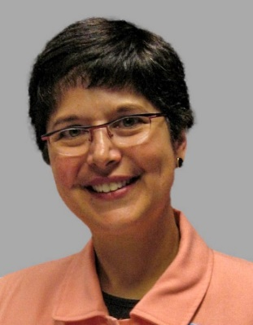
I started researching my family history at a young age—and still have my handwritten notes from interviewing my grandparents more than 50 years ago! Over the decades, I interviewed relatives, explored cemeteries, searched for archival records, viewed microfilms, wrote thousands of letters, and travelled the world to find cousins. As an attorney by profession, I applied my analytical and project management skills to complex genealogy research projects for family, friends, and clients.

My first trip to Eastern Europe was in 1991, as communism was being dismantled in the region. I was named a Fulbright Scholar in 2002 and awarded a U.S. government grant to teach law in Latvia. I returned to Eastern Europe to teach law in Moldova in 2006 and 2007 as a Fulbright Senior Specialist. While living and working in Eastern Europe, I traveled extensively throughout the region. I made trips to ancestral towns, and visited state archives in Lithuania, Poland, Ukraine, Moldova, and other countries.

I often speak at conferences and to groups on Eastern Europe and Jewish genealogy topics. I have also developed educational courses on Eastern Europe and genealogy, including the Tracing Your Eastern European Roots course at the Genealogical Research Institute of Pittsburgh.

I have been a dedicated volunteer for many years. I am a Past President of the Jewish Genealogy Society of Cleveland (JGSC), having served as President during 2016 and 2017 and as Treasurer for two years prior thereto. I currently serve as the Trakai District coordinator, and previously served on the Board of Directors, for LitvakSIG, Inc. I’ve also served on the International Association of Jewish Genealogical Societies (IAJGS) Public Records Access Monitoring Committee and as an IAJGS Representative to the Records Preservation Access Committee known as RPAC. Additional IAJGS volunteer activities included service on the Bylaws Revision Committee and Nominating Committee. I am also the long-time administrator of the Facebook Pages for JGSC and LitvakSIG.

